Self-Diagnosis and Self-Healing (SDSH) Indoor Air Quality (IAQ) Sensor Network for Effective Demand-Controlled Ventilation
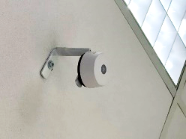  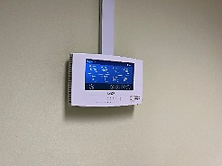  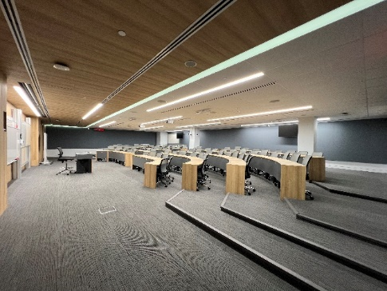  Wired sensors  Wireless sensors  SDSH IAQ sensor network driving demand-controlled ventilation for better energy efficiency and air quality  In order to achieve energy efficiency, a Demand Controlled Ventilation (DCV) system is typically implemented, where the rate of fresh air supplied to an indoor space is adjusted automatically based on the actual demand instead of a pre-defined fixed volume rate. To measure the demand, one CO2 sensor is installed per air handling unit (AHU) to determine the CO2 concentration in the area. However, as the floor area that each AHU covers might have a differing usage pattern or user density, the CO2 sensor in the AHU may not be able to detect that certain heavy usage areas such as meeting rooms have poor air quality with high CO2 concentration, as it only detects the average of the CO2 levels across the whole floor area.  To ensure optimum indoor air quality for all buildings, which is especially critical during the pandemic, a localised ventilation control system with a larger sensor network distribution is necessary. Additionally, it also offers more energy savings due to its ability to adjust the ventilation rates to tailor the supply of fresh air based on the actual demand. Though economically-viable, low cost sensors have limited accuracy and reliability when used in the long term.  The team of scientists from A*STAR’s National Metrology Centre (NMC) found that such sensors are susceptible to sensor drift of more than 10% per year, where the sensors’ gradual decline reduces their accuracy, leading to almost 10% more energy wastage. To combat the issue of drifting sensors, a data-driven and autonomous calibration method was developed, where the Self-Diagnosis and Self-Healing (SDSH) algorithm monitors sensor health continuously and automatically compensates for sensor drifts upon detection. Furthermore, it notifies the building maintenance team to repair or replace faulty sensors that cannot be restored through calibration due to excessive sensor drift. The SDSH technology thus minimises the need for labour intensive and costly on-site or lab-based calibration, as well as reduces the frequency of operations being interrupted during physical calibrations due to the unavailability of sensors.  By combining SDSH and localised ventilation control, building owners can potentially expect 20% more energy savings as compared to the current demand-controlled ventilation system, while enjoying a greater peace of mind with the improved accuracy of their sensor networks and indoor air quality for better health and comfort of the building occupants.  Under the SMU Industrial Collaboration Initiative of Creating Meaningful Impact, the system has been installed in existing office and teaching spaces at Basement 2 of Yong Pung How School of Law, Singapore Management University, where its functions and expected energy saving capabilities are demonstrated in a live setting. | Applications:  - To provide reliable sensing for better building energy efficiency, such as for demand-controlled ventilation and more  Capabilities:  - Real-time and reliable air quality monitoring  - Energy efficient demand-controlled ventilation  - Autonomous sensor performance monitoring and drift correction with measurement traceability to the International System of Units (SI), for enhanced reliably in sensing data  - Alarm function to notify maintenance staff to repair or replace unreliable sensors  Benefits:  - Potential energy savings of 20% through localised ventilation control  - Reducing energy wastage due to sensor drift  - Reducing system maintenance downtime and long-term sensor maintenance cost by using data-driven and remote calibration to replace current laboratory and onsite calibrations that is commonly done  - Ensuring adequate IAQ for occupant’s health and productivity  Contact Information:  Dr. Cui Shan  cui_shan@nmc.a-star.edu.sg  National Metrology Centre  8 CleanTech Loop, #01-20, Singapore, 637145  http://www.a-star.edu.sg/nmc
Project Principal Investigator: Dr. Cui Shan, National Metrology Centre, A*STAR
Project supported by GBIC R&D

